Abbeydale Archers
Grand National Open Pie and Pea Shoot 05/04/2025
Name | Email | Contact No | Club | Bow | Age | AGB No | Lunch

£10.00 No Lunch £13.00 With Lunch

Payment: via BACS – Sort code 60-19-07, Acc. 56378572 Abbeydale Archers

Entries to: David Corker
Email rats@abbeydalearchers.com

Results: Results sheets will be available via email on request to: rats@abbeydalearchers.com and on the website

Round: National round

Assembly: 10:00am Sighters: 10:30am

Dress code: AGB dress code preferred.

Refreshments: Bacon sandwiches, tea and coffee will be available on arrival.

Lunch: Steak Pie or Vegetarian Steak Pie and Mushy Peas. Please state in the form above.

Entries: Please note that entries cannot be accepted without a AGB number or a signature (parent or guardians for juniors). A parent or Guardian must remain on the field for the competition.
AGB membership cards must be produced on request.

Closing date: Please submit entries before: 29/03/2025

Awards:
Gentlemen/50+ and Jnr: Recurve/Barebow/Compound/Longbow- 1st, 2nd and 3rd Medals
Ladies/50+ and Jnr: Recurve/Barebow/Compound/Longbow- 1st, 2nd and 3rd Medals
Team: – 1st Place awarded

Judges TBA

Please Note:
The site is a double camber slope which is not conducive to wheelchair users. Although every care is taken to accommodate all archers please contact the event organiser prior to application, to ensure individual needs can be accommodated. Alternatively, you may be advised to bring your own assistant on the day.

Important Notice:
3.6 The open carry of Knives is not permitted on the field
Open Carry is the practice of publicly carrying a knife that is fully or partially visible.
This include if the knife is in a sheath. Knives may still be used for equipment maintenance and arrow retrieval.
If you carry a knife on a belt please remove it for the tournament, You will be asked to remove knives from belts.

Photography: In accordance with the AGB Protection of Children and Vulnerable Adults Policy, those who wish to take photographs at this event should register with the Tournament Organiser on arrival. No unauthorised photography will be permitted.

Disclaimer: Abbeydale Archers cannot accept liability for any injury, illness, loss or damage to
any person or property incurred during this event.

I consent for Abbeydale Archers to collect, store and process the following personal data for the purposes of: The Grand National Shoot:. Name, Date of Birth, Archery GB number, Email, Contact No and Archery Club. Yes ☐ No ☐

Results – I consent for Abbeydale archers to publish my name, Archery club and score on the tournament results to be published on the Abbeydale Archers website and Facebook. Yes ☐ No ☐
We are unable to accept an entry to the tournament without a YES to accept due to the GDPR laws now in effect.
Abbeydale Archers
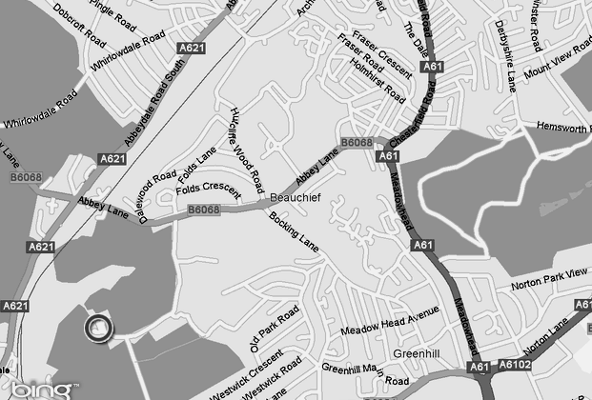
De La Salle Club
Beauchief Abbey Lane
Sheffield
S8 7BA
Please Arrive Via Abbey Lane – Beauchief Abbey.

Postcode S8 7DB
What 3 Words: bank.buzz.fixed

