Abbeydale Archers
Open Potato Shoot 15/09/2023
Name | Email | Contact No | Club | Bow | Age | AGB No | Lunch

£10.00 No Lunch | £13.00 With Lunch | Potato Filling | Chilli | Cheese

Payment: via BACS – Sort code 60-19-07, Acc. 56378572 (Please email to advise payment has been sent), or please post your cheque made payable to “Abbeydale Archers” to contact below:

Entries to: David Corcker
38 Humphrey Road, Sheffield, S8 7SE
Email rats@abbeydalearchers.com

Results: Results sheets will be available via email on request to: rats@abbeydalearchers.com and on the website

Round: Western round

Assembly: 10:00am Sighters: 10:30am

Dress code: GNAS dress code preferred.

Refreshments: Bacon sandwiches, tea and coffee will be available on arrival.

Lunch: Lunch - Jacket potato & chilli, cheese or vegetable chilli – pre-order on entry form please.

Entries: Please note that entries cannot be accepted without a GNAS number or a signature (parent or guardians for juniors). GNAS membership cards must be produced on request.

Closing date: Please submit entries before: 08/09/2023

Awards:
Gentlemen: Recurve/Barebow/Compound/Longbow- 1st, 2nd and 3rd Medals
Ladies: Recurve/Barebow/Compound/Longbow- 1st, 2nd and 3rd Medals
Team: – 1st Place awarded

Judges TBA

Please Note:
The site is a double camber slope which is not conducive to wheelchair users. Although every care is taken to accommodate all archers please contact the event organiser prior to application, to ensure individual needs can be accommodated. Alternatively, you may be advised to bring your own assistant on the day.
Importance Note
3.6 The open carry of Knives is not permitted on the field
Open Carry is the practice of publicly carrying a knife that is fully or partially visible.
This include if the knife is in a sheath. Knives may still be used for equipment maintenance and arrow retrieval.
If you carry a knife on a belt please remove it for the tournament, You will be asked to remove knives from belts.

Photography: In accordance with the GNAS Protection of Children and Vulnerable Adults Policy, those who wish to take photographs at this event should register with the Tournament Organiser on arrival. No unauthorised photography will be permitted.

Disclaimer: Abbeydale Archers cannot accept liability for any injury, illness, loss or damage to
any person or property incurred during this event.

I consent for Abbeydale Archers to collect, store and process the following personal data for the purposes of: The Potato Shoot. Name, Date of Birth, Archery GB number, Email, Contact No and Archery Club. Yes ☐ No ☐

Results – I consent for Abbeydale archers to publish my name, Archery club and score on the tournament results to be published on the Abbeydale Archers website and Facebook. Yes ☐ No ☐
We are unable to accept and entry to the tournament without a YES to accept due to the GDPR laws now in effect.
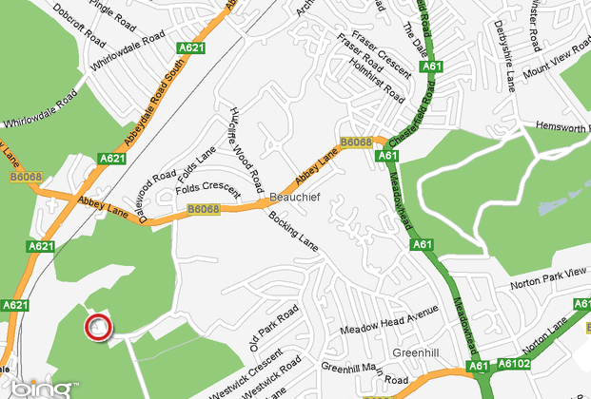
Abbeydale Archers
De La Salle Club
Beauchief Abbey Lane
Sheffield
S8 7BA
Please Arrive Via Abbey Lane – Beauchief Abbey.

Postcode S8 7DB
What 3 Words: bank.buzz.fixed

